Our Setting’s Safeguarding Poster Pack

Do not print this explanation page.

It is vital that safeguarding information is displayed and accessible to staff, volunteers, parents, carers and other
external visitors

- There are 4 useful posters that all education settings are encouraged to use.

- How our Setting Safeguards Students

- Safeguarding at our Setting

- The Safeguarding Children Team in our setting

- Snapshot of our Setting

- The posters are all editable so they can be tailored to your setting.

- When populated with your setting’s information please display at reception areas and communal areas as appropriate.

How our Setting Safeguards Students

We understand that safeguarding and promoting the welfare of children is everyone’s responsibility and fully endorse the core principles of safeguarding:
- Protecting children from maltreatment (A child is anyone under 18 years old)
- Preventing impairment of children’s mental and physical health or development
- Ensuring that children grow up in circumstances consistent with the provision of safe and effective care; and
- Taking action to enable all children to have the best outcomes.
We are child-centred and we will always promote students’ health, well-being, personal and emotional development.
We create a safe, inclusive learning culture where students;  - Are respected and protected from bullying and discrimination.  - Can talk and express views, be listened to and get feedback.  - Have their needs met and fulfil their potential?  - Know how to get help.  - Know when discussion is confidential.  - Learn about online-safety, bullying, healthy relationships, abuse, neglect, exploitation | We work in partnership with parents and carers by offering;  - Open, honest, and respectful relationships  - Comfort and privacy to talk and get advice.  - Involvement and inclusion at all stages of student’s education and care  - Understanding of culture and diversity  - Clear explanations and use of professional interpreters  - Up-to-date emergency contact details  - Information about our complaints procedure  Support and signposting to adult services if vulnerable
We promote early help and support by:  - Prompt identification and assessment of additional needs of all students and their family  - Putting ongoing support in place, with a clear planning and review cycle  - Sharing information appropriately with students, families and agencies  - Preventing concerns from escalating | We store and share information securely by:  - Following legislation and guidance  - Having appropriate IT filters and monitoring systems in place  - Explaining how, what, where and when information is shared.  - Maintaining detailed, accurate and secure written records of discussions, decisions and actions, and sharing appropriately
Our Safeguarding policies and procedures:  - Available publicly for students, families, staff  - Following National and SCSP guidance and arrangements (e.g. Keeping children safe in education)  - Include staff/pupil behaviour and relationships, and online communications.  - Updated annually | We have a coordinated approach to concerns:  - There is quick staff response to inform DSL/D about student concerns.  - There are timely referrals to Children’s Social Care and Police where risk of significant harm exists.  - We work with all agencies to support students and families through multi-agency meetings e.g., child protection conferences, plans and actions
We have safe recruitment and management practices by ensuring that:  - Unsuitable people do not work with children.  - There is a positive, open culture and environment.  - Whistleblowing process for staff concerns about organisational practice are in place.  - All allegations of abuse by staff, carers or volunteers are reported using the correct procedures | Our trained volunteers, staff and management have:  - Clear safeguarding roles and responsibilities  - On-site safeguarding induction and refreshers  - High quality SCSP basic and advanced staff training  - Regular DSL/D staff safeguarding updates of skills and knowledge

Safeguarding at Totley All Saints

- If you have any concerns about a student at Totley All Saints, please share this information with us straight away.
- Issues such as appearance, hygiene, behaviour, can be shared with teaching or support staff.
- Do not worry about reporting small matters – we would rather you tell us than miss a worrying situation.
- If you think that a student or an adult who cares for them has been or might be harmed; please talk to a member of our trained safeguarding team immediately (details below).
- You can ask any member of staff to find them and speak to you about a confidential and urgent matter.

- If you are unhappy with the way we have dealt with something, please tell us.
- If you wish to report it to us formally, please use our complaints procedure or write directly to the Head Teacher or Chair of Local School Board.
- A concern, allegation or disclosure of abuse involving someone working with children or adults in a paid or unpaid capacity must be reported directly to the Head Teacher, unless it involves them and then it should be reported directly to the Chair of the Local School Board or DSAT

Our Head of School and Designated Safeguarding Lead is:  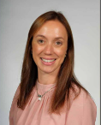  Name: Melissa Drake  Her office is located next to Reception  Their tel. no is:  0114 2361934 |  | Our Deputy Designated Safeguarding Lead is:  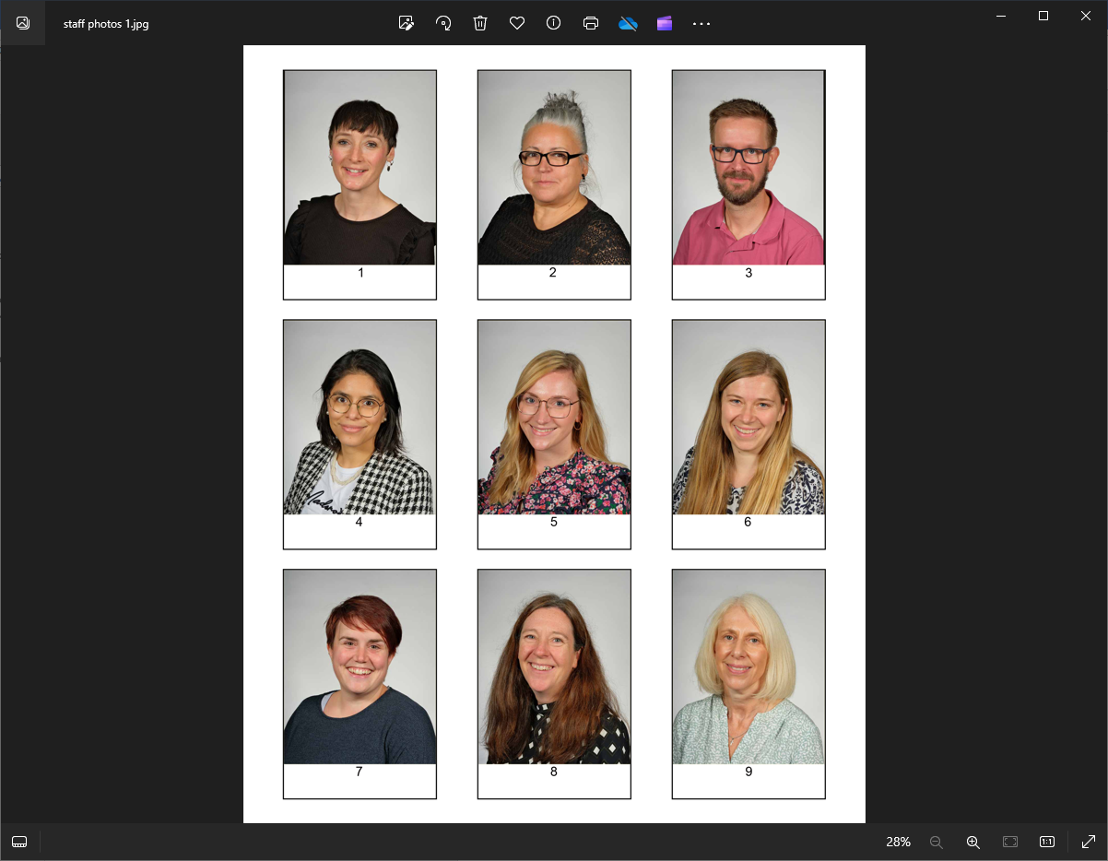  Name: Rebecca Keen  Her classroom is opposite the Library  Their tel. no is:  0114 2361934

Our Special Educational Needs Coordinator is:  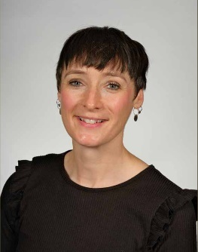  Name: Rebecca Underwood  Their classroom is located in Foundation  Their tel. no is:  0114 2361934 |  | The Deputy CEO and Trust Lead for Safeguarding is:  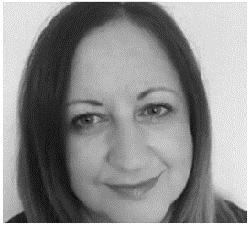  Name: Alison Adair  Their tel. no is:  01709 718640 Option 1

The Safeguarding Children Team in our setting:
Headteacher: | Responsible for implementing policies and procedures, allocating resources to the safeguarding team and addressing staff safeguarding concerns.  Name: Melissa Drake Tel no: 0114 2361934
Designated Safeguarding Lead (DSL): | Teaching or pastoral staff from senior leadership team, responsible for all safeguarding issues, advising and supporting staff, liaising with the local authority and other agencies.  Name: Melissa Drake Tel no: 0114 2361934
Designated Safeguarding Deputy (DSD): | A teacher, support or pastoral worker, in a post which requires assessment of children, deputises for the DSL. Not an administrative or finance worker.  Name: Rebecca Keen Tel no: 0114 2361934
Child Sexual Exploitation (CSE) Lead: | Support for pupils and staff to understand CSE and related topics and how to refer.  Name: Melissa Drake and Rebecca Keen Tel no: 0114 2361934
Special Educational Needs and Disabilities Coordinator (SENDCo): | Support for staff and other agencies working with pupils with special education needs and disabilities and their parents and carers.  Name: Rebecca Underwood Tel no: 0114 2361934
Children Looked After (CLA) Designated Teacher: | Promotes the education of ‘looked after’ and previously ‘looked after’ children.  Name: Melissa Drake Tel no: 0114 2361934
Online-Safety Coordinator: | Develops and maintains a safe online culture within a setting, must also be a DSL/D  Name: xxx Tel no: 0114 2361934
Safeguarding/  Child Protection Governor: | Ensures there are appropriate policies and procedures in place, that they are being implemented and followed, and challenges deficiencies and weaknesses that are identified.  Name: Alison Adair Tel no: 01709 718640 Option 1
Management Committee: | Leads on safe recruitment and allegations of abuse against Head Teacher/Principal/Senior Manager and other staff and liaises with Local Authority  Name: Alison Adair Tel no: 01709 718640 Option 1
SENDCo Governor: | Link between the SEND Coordinator (SENDCO) and the governing body/management committee  Name :Alison Adair Tel no: 01709 718640 Option 1
Learning Mentor (or equivalent): | Develops strategies and support to help pupils achieve their full potential.  Name: Melissa Drake Tel no: 0114 2361934
Education Welfare Officer (or equivalent): | Addresses difficulties preventing pupils from attending school.  Name : Alison Hallewell Tel no: 01709 718640 Option 2
Counsellor: | Provides mental health support and advice to pupils.  Name : Melissa Drake Tel no: 0114 2361934
Medical Practitioner: | Supports pupils’ medical needs, ill health absence, medicines and individual healthcare plans.  Name : Melissa Drake and Rebecca Underwood Tel no: 0114 2361934

