**Totley All Saints**

**Church of England Primary School**

**Handwriting**

**Policy**



**Subject Leader: Emily Scarpello**

**September 2023**

“I have come so that they should have life and live it to the full.”

**Totley All Saints Handwriting Policy**

At Totley All Saints, we aim for our children to leave in Year 6 with the ability to write using their own style of fast, fluent, legible and sustainable handwriting, as well as other styles of writing for specific purposes. In addition to teaching handwriting during our regular handwriting lessons, we have high expectations that what is taught and practiced in handwriting lessons will be used in all writing activities. We believe that handwriting is integral to a child’s personal development and know that children’s engagement and self-esteem can be improved by their satisfaction and pride in good quality presentation.

**Aims**

Handwriting is a taught skill that develops at different rates for different children. All of the teachers in the school put a priority on teaching handwriting and have high expectations for handwriting across the curriculum. Our school uses Penpals for Handwriting to ensure that:

• The importance of handwriting is recognised and given appropriate time.

• The progression of handwriting is consistent across the school.

• Handwriting is acknowledged to be a whole body activity and emphasis is placed on correct posture and pencil grip for handwriting.

• Expectations of left-handed children are equal to those of right-handed children, and appropriate advice and resources are available to ensure that they learn to write with a comfortable, straight wrist.

• Handwriting is linked into grammar, punctuation and spelling in order to practice and contextualise all of the transcriptional and stylistic skills for writing.

• Children learn to self-assess their own writing and develop understanding and responsibility for improving it.

• Children learn to write in different styles for different purposes such as print for labelling a diagram, illustrated capitals letters for creating a poster, swift jottings for writing notes, making a ‘best copy’ for presentation and fast, fluent and legible writing across the curriculum.

**Progression of skills**

Penpals enables us to teach and secure the development of handwriting throughout the school:

• In the Early Years, children experience the foundation of handwriting through multi-sensory activities.

• Correct letter formation is taught, practised, applied and consolidated (FS2/Y1). In FS2 we use Little Wandle Letters & Sounds to introduce letter formation through visuals and mnemonics so that handwriting can be linked with early segmenting and spelling using correct letter formation.

• Joining is introduced only after correct letter formation is used automatically (Y1/Y2/Y3).

• Joins are introduced systematically and cumulatively (Y2–Y6).

• As children practice joining, they pay attention to the size, proportion and spacing of their letters and words (Y3–Y6).

• Once the joins are secure, a slope is introduced in order to support increased speed and fluency (Y5).

• Children are introduced to different ways of joining in order that they can develop their own preferred personal style (Y6).

In using Penpals, we ensure that our children follow the requirements and recommendations of the National Curriculum. We share the aspirations that children’s handwriting should be ‘sufficiently fluent and effortless for them to manage the general demands of the curriculum’ and that ‘problems with forming letters do not get in the way of their writing down what they want to say’.

**Handwriting tools**

Throughout their time in school, children use a range of tools for different purposes and styles of handwriting including:

• A wide range of tools and media for mark-making in the EYFS.

• Whiteboard pens throughout the school.

• Fingers or pen writing on the interactive whiteboard.

• Art supplies including coloured pens and pencils for posters, displays and artwork.

• Sharp pencils for most writing until a pen licence is awarded.

• A handwriting pen for when they sustain a good level of presentation.

Handwriting is always introduced and practised on whiteboards and in handwriting books with lines so that children quickly learn about letter orientation including ascenders and descenders. As children’s fine motor skills improve and their letter formation or joining becomes increasingly accurate, the width between the lines they write on gradually decreases.

**Handwriting Grip, Pencil Hold and Control**

We plan a series of small steps activities in FS2, to enable children to develop the necessary skills to control a pencil in order to write effectively. A careful balance is needed between muscle tone, co-ordination, pro-prioception and sensation.

Stage 1

Initially, we aim to develop the control required for the exact placement of the pencil on a specified point to develop hand-eye co-ordination. This also requires controlled pressure so that the child learns how much to apply in order to make a mark. Alongside this the child learns when to place their hand down onto the page and when to lift it again, thus creating the mark desired. A range of media and tools are used to place dots on a specified place on the page.

Stage 2

In the next stage of our small steps teaching, we plan a range of grasping skills, such as picking up small objects with fingers, squeezing, manipulating objects, threading and fingerplay.

Stage 3

Next we begin to create muscle memory using a variety of large gross motor movements, using paint, ribbons in the air, sticks in sand, big brushes and water to create patterns on the floor. Children begin to go “around” letters.

Stage 4

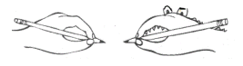Finally, we teach pencil grip using the crocodile snap method:

- Child’s dominant hand is a crocodile

- Practice opening and closing the crocodile’s mouth

- Now that the alligator is holding the pencil in his mouth, place the pencil on the bottom jaw of the

alligator and close the alligator’s mouth on the pencil.

- He puckers his lips and curls his jaws in the shape of an ‘o’ – and clenches the pencil in his teeth.

Children practice proper grip before colouring and drawing tasks, and gain repeated practice through activities such as drop and pick up a pencil to increase finger placement. At this stage, children use small writing tools such as short chalk or markers or short/broken crayons which are ideal writing tools for little hands, as they create natural resistance for increased hand strength.

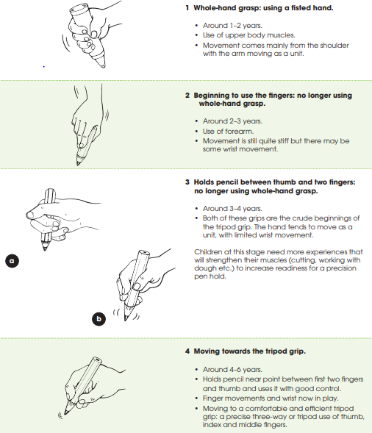Developmental Levels of Pencil Hold

**Regular Handwriting Lessons**

Handwriting is taught in short but regular sessions to allow spaced retrieval and repeated practise throughout the week. We use the DSAT Teach Simple Model to give children opportunities to; retrieve prior learning and strengthen long-term memory; access precise small steps teaching which is well modelled; practise the learning with appropriate scaffolds which fade when appropriate; and apply their learning in context/s. Throughout these stages, assessment is used to inform progress with timely feedback for children, using metacognition and self-regulation to promote active learning.

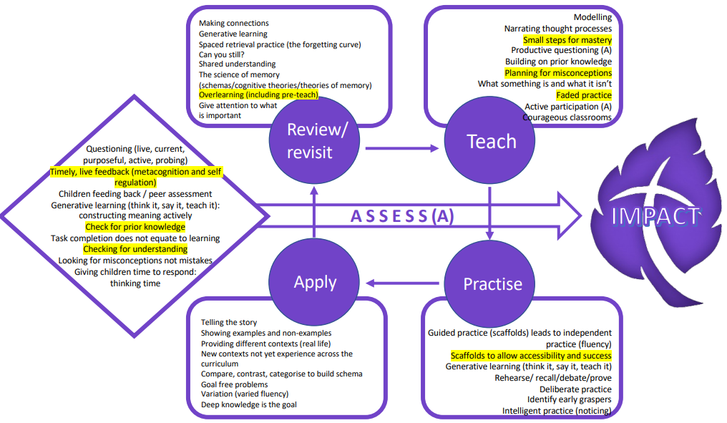

DSAT Teach Simply Model

|  |  |  |
| --- | --- | --- |
| **Handwriting Session** | **Retrieval** | **Teach & Practise** |
| **1** | Warm-up  Retrieve previous letters/joins/words | Sky writing/pattern practice.  Introduce & practice the new letter/join/style. |
| **2** | Warm-up  Retrieve new letter/join/style | Teach and practice words containing the new letter/join/style. |
| **3** | Retrieve new letter/join/style & some of the words already practiced | Examine samples of writing from the handwriting interactive resource or own collected sample e.g. from children’s work. Identify focus letter/join/style in the sample & discuss.  Chn rewrite the sample. |
| **4** | Retrieve words practiced | Dictated sentence or rewrite a section of their own writing across the curriculum that contains the target letter/join/style. |

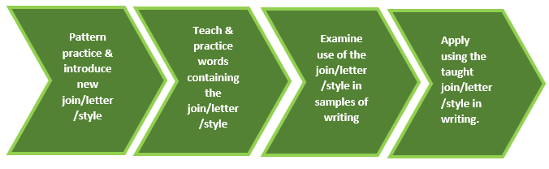

**Equality of opportunity**

At Totley All Saints, we have a high ambition for all children regardless of their background or barriers to learning. Our most vulnerable pupils, including our pupil premium pupils and pupils with SEND have equal access to handwriting lessons and to the resources available. We recognise that some children may take longer to develop the necessary skills and we cater for those children by; providing adapted resources such as additional scaffolds or small steps; pre-teaching learning to reduce working memory overload and give children a chance of success in lessons; targeted support from a TA using the Scaffolding Pyramid (see below), or additional opportunities for skills development using appropriately pitched practise. Children who need specific fine motor or handwriting adaptations or interventions are identified early and the impact of adaptations or intervention is carefully monitored. Children with a physical disability are catered for, and progress is monitored, according to their individual action plans.

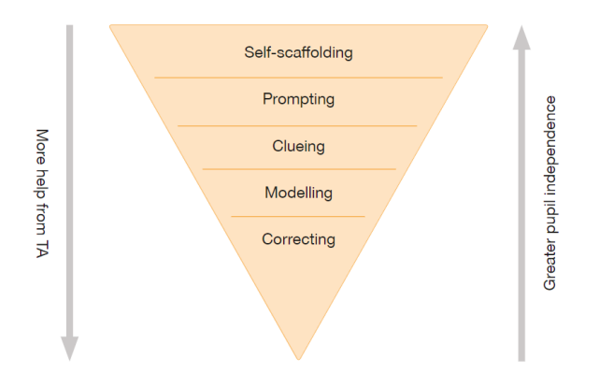The Scaffolding Pyramid

**Assessment**

Using our Teach Simply Model, teachers make formative assessment judgements throughout handwriting lessons about pencil hold, paper positioning, posture and mastery of the letter/join/style being taught. Each half-term, a short sample of writing is collected for the teacher to assess the impact of the skills teaching for the half-term. PenPals assessment lessons are also taught as they appear in the teaching sequence. Children who may need additional practice or smaller steps teaching are monitored carefully to ensure they make progress.