

English Policy

Subject Leader: Emily Scarpello

Last reviewed: January 2025

Next review due by: January 2027

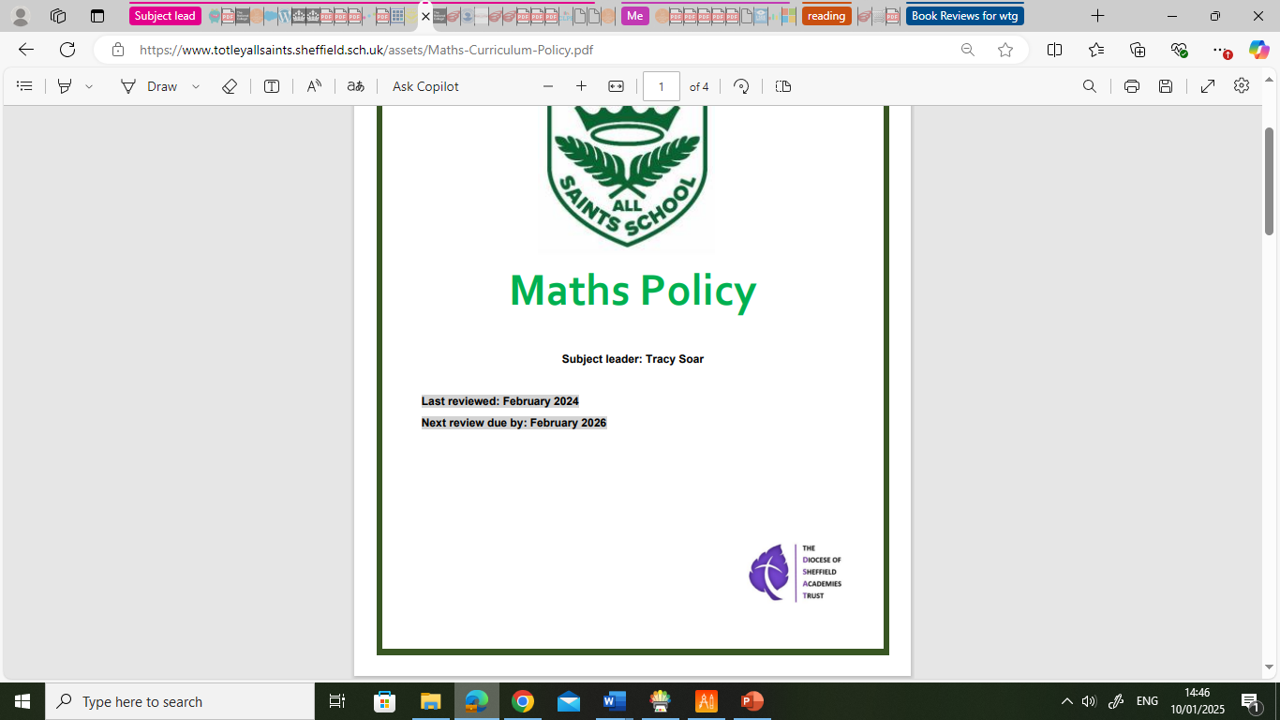

Intent
THE TASS COMMUNITY: GROWING AND LEARNING TOGETHER

‘At Totley All Saints Church of England Primary School, we aim to be an exceptional school with Christian values at the very heart of the community. We are committed to providing an environment where every child can thrive & is supported to achieve their unique & amazing potential as a child of God.’

“I have come that they may have life, and have it to the full.” John 10:10

Rationale

English has a pre-eminent place in education and in society. A high-quality education in
English will teach pupils to speak and write fluently so that they can communicate their ideas and emotions to others and through their reading and listening, others can
communicate with them. Through reading in particular, pupils have a chance to develop
culturally, emotionally, intellectually, socially and spiritually. Literature, especially, plays a
key role in such development. Reading also enables pupils both to acquire knowledge and
to build on what they already know. All the skills of language are essential to participating
fully as a member of society; pupils, therefore, who do not learn to speak, read and write
fluently and confidently are effectively disenfranchised.

At Totley All Saints, we endeavour to equip all of our children with a love for the English language in its written and spoken forms. We promote high standards of language and literacy by equipping pupils with a strong command of the spoken and written word, and to develop their love of literature through widespread reading for enjoyment.

- We encourage children to develop skills to communicate effectively in speech and writing, to listen with understanding and to be responsive, enthusiastic and knowledgeable readers.
- We recognise English as a core subject in the National Curriculum and as a pre-requisite for educational and social progress empowering children to communicate creatively and imaginatively.
- We aim to provide an environment for language development that is stimulating and is characterised by high expectations of success so that the fullest potential of each individual may be achieved.

Aims of the Policy:
At TASS we strive to provide children with access to an integral programme of speaking and listening, reading and writing to foster a love of language, a curiosity about how language works and to strive for excellence in all areas.
We aim:
- To deliver the statutory National Curriculum for English in a well-sequenced, progressive and inclusive way so that children from whatever background and of whatever ability can succeed;
- To provide children with the necessary skills to become competent, creative and efficient users of the English Language to prepare them for secondary school and to enable them to become successful in their later lives;
- To provide children with successful English role models to increase aspiration;
- To provide children with meaningful, engaging contexts for reading and writing.
- For the skills that children develop in English to be applied in every subject of our curriculum. The children’s skills in reading, writing, speaking and listening enable them to communicate and express themselves in all areas of their work at school.

Approaches to Teaching English

Reading
Reading is taught through small groups in FS2 – Y1 using phonetically decodable books matched to children’s current ability, following the three times a week structure of; decode, prosody & comprehension. From Y2-Y6 reading is taught through whole class book study using quality novels and Cracking Comprehension.
Through our teaching of reading, children learn to:
- decode to read unknown words, to develop automaticity through repeated reading (especially in the earlier years), and build sight recognition of ‘tricky’ but high frequency words;
- use higher order reading skills including deduction and inference through the use of text referral, assessment of authors’ intentions, justification of their opinions and judgements in the pursuit of critical awareness;
- engage with a range of texts both fiction, non-fiction and poetry with confidence, fluency, enjoyment and understanding.

Writing
Daily English lessons use high quality inspiring texts, well-planned and sequenced small steps, a teach-task approach to learning, teacher modelling and precision teaching of skills. Children’s learning is supported through the use of stem sentences, word mats, spelling banks, dictionaries and thesauruses, scaffolds and faded practice. Dictated sentences are regularly used to promote transcriptional skills and ‘holding a sentence in your head’ as well as a focus on accuracy of spelling, punctuation and application of recently taught skills. All lessons have purposeful SPaG practice embedded within them. We follow the ‘Teach Simply Model’ of review, teach, practise, apply, and the learning objectives for each sessions are shared with the class so that pupils can understand the aim of the lesson and assess whether they have been successful.

Our Lessons provide children with the opportunities to:
- use grammar and punctuation correctly to attain high levels of English writing
- understand and use technical vocabulary when discussing their reading and writing
- understand the sound and spelling system and use this to read and spell accurately through daily phonics lessons in EYFS, Y1 and into Y2, and through regular spelling instruction in KS2 using the Read, Write Inc. Spelling programme
- write to a high standard in a variety of styles and forms showing an awareness of audience and purpose
- write with fluent, legible joined handwriting and take pride in the presentation of all of their work (with regular handwriting instruction and practice, in discreet lessons and across the curriculum)
- encounter a range of texts through our carefully planned and sequenced curriculum which has small steps identified and clear end of year points
- be immersed in a text or stimulus, to explore the style of writing and examine genuine author written models, enabling them to plan, draft, revise, edit and publish their own writing inspired by the same purpose, style and audience (see EEF KS2 guidance on the Process Approach to Writing).

Cross-Curricular Links
- Pupils are given regular opportunities to use and transfer the English skills that they are learning, in order to read and write competently throughout the range of subjects taught in school.

Our commitment to our children by the age of 11 is to be able to:
- Be effective, competent communicators within a range of groups in both formal and informal contexts;
- Develop key skills in all areas of language including speech.
- Listen carefully with good concentration and be able to respond thoughtfully and appropriately;
- Read a range of texts both fiction and non-fiction with confidence, fluency, enjoyment and understanding to enable them to develop preferences and make informed choices.
- Write to a high standard in a variety of styles and forms showing an awareness of audience and purpose;
- Write with fluent, legible joined handwriting and take pride in the presentation of all of their work.

Assessment:
- In line with the Assessment policy, pupil’s English skills are assessed through ongoing formative and termly summative assessments as well as Optional SATs at the end of KS1 and SATS at the end of KS2.
- Live marking and feedback is utilised in lessons to identify next steps and catch errors at the time in which they are being made or shortly afterwards. Self and Peer marking, and corrections are also used to develop children’s evaluative and editing skills.
- FS2 use the “Ages & stages” document to inform their assessments working towards the Early Learning Goals.

Inclusion:
- At TASS we will ensure that all children receive quality English teaching on a daily basis.
- All children are given equal access to the English curriculum. We use adaptive teaching approaches to meet the needs of pupils with special educational needs, those with disabilities, those with special gifts and talents, and those learning English as an additional language. For further details see separate policy for Special Educational Needs.
- Adaptive teaching may include visual supports, use of Communicate in Print, further scaffolds or stem sentences, pre-teaching, post-teaching, extended practice, additional support, and more.
- Children who are able to work at a greater depth are given suitable challenges to broaden their application of knowledge and extend their thinking.
- Children who are working below age-related expectations are appropriately supported in lessons and receive intervention, if appropriate, to ensure they make accelerated progress (this may be additional 1:1 reading, Herts Reading Fluency intervention programme, Keep-Up or Rapid Catch-up, pre-teaching, post-teaching, additional transcription through spelling, handwriting or additional dictation, or grammar practice as necessary).
- We understand that children need to read texts that are ‘windows’ or ‘mirrors’ or reflect their own lives and the lives of others around them, and so we strive to provide a range of texts and activities which reflect the diversity of our society.
Role of the English Leader
The Subject Leader is responsible for improving the standards of teaching and learning in phonics & English through:
- Monitoring and evaluating English teaching and learning:
- Pupil progress
- Provision of English
- The quality of the Learning Environment
- Taking the lead in policy and curriculum development
- Auditing and supporting colleagues in their CPD
- Purchasing and organising resources
- Keeping up to date with recent research and developments

Monitoring and review
The English Leader regularly monitors planning, pupils books, drops into lessons and talks to pupils to ensure the consistency of teaching and learning in English throughout school.
The SLT regularly discuss the progress of the subject within school, prioritises development within the subject in the School Development Plan and holds termly Pupil Progress Meetings to discuss the progress pupils are making with the class teacher/s, subject leader and SENDCo. Next step plans are put into place for classes, groups of pupils or individuals following these and support is planned for teachers, if needed.

The role of the Local School Board:
The governors of TAS are fully involved in the promotion of this policy in school and are reported to regularly on pupils’ achievement and attainment, and are involved in:
- recent development work
- performance analysis in relation to the School Development Plan
- pupil outcome analysis in relation to development priorities and their impact upon teaching and learning
- future developments in accordance with the School Development Plan
- working closely with the English Leader to monitor an agreed agenda regarding the children’s attainment and achievement in English.
Parental involvement
At TASS we recognise parental involvement is vital to the development of each child’s English skills. We believe that a strong Home-School partnership actively promotes children’s progress and achievement.
Regular reading at home of books carefully matched to age/ability, significantly supports children’s learning. Particularly so in the younger years, repeated reading of the same materials and with an adult then increasingly alone helps to build fluency and confidence. Reading at home with parents, grandparents or brothers/sisters should be seen as an enjoyable activity which fosters a love of books. Reading and the enjoyment of reading is the key to success at school and children are also encouraged to make their own book selections from class libraries and the school library to supplement their reading diet.
All children have a reading record for parents to note and comment on reading at home; this provides a valuable link between school and home.

Homework is also plays an important part in developing children’s skills through learning spelling rules or GPCs to consolidate the learning that is taken part in school, each week. Each half-term the Cracking Comprehension practice texts are also shared with parents for children to practice reading at home to support their learning in class.

